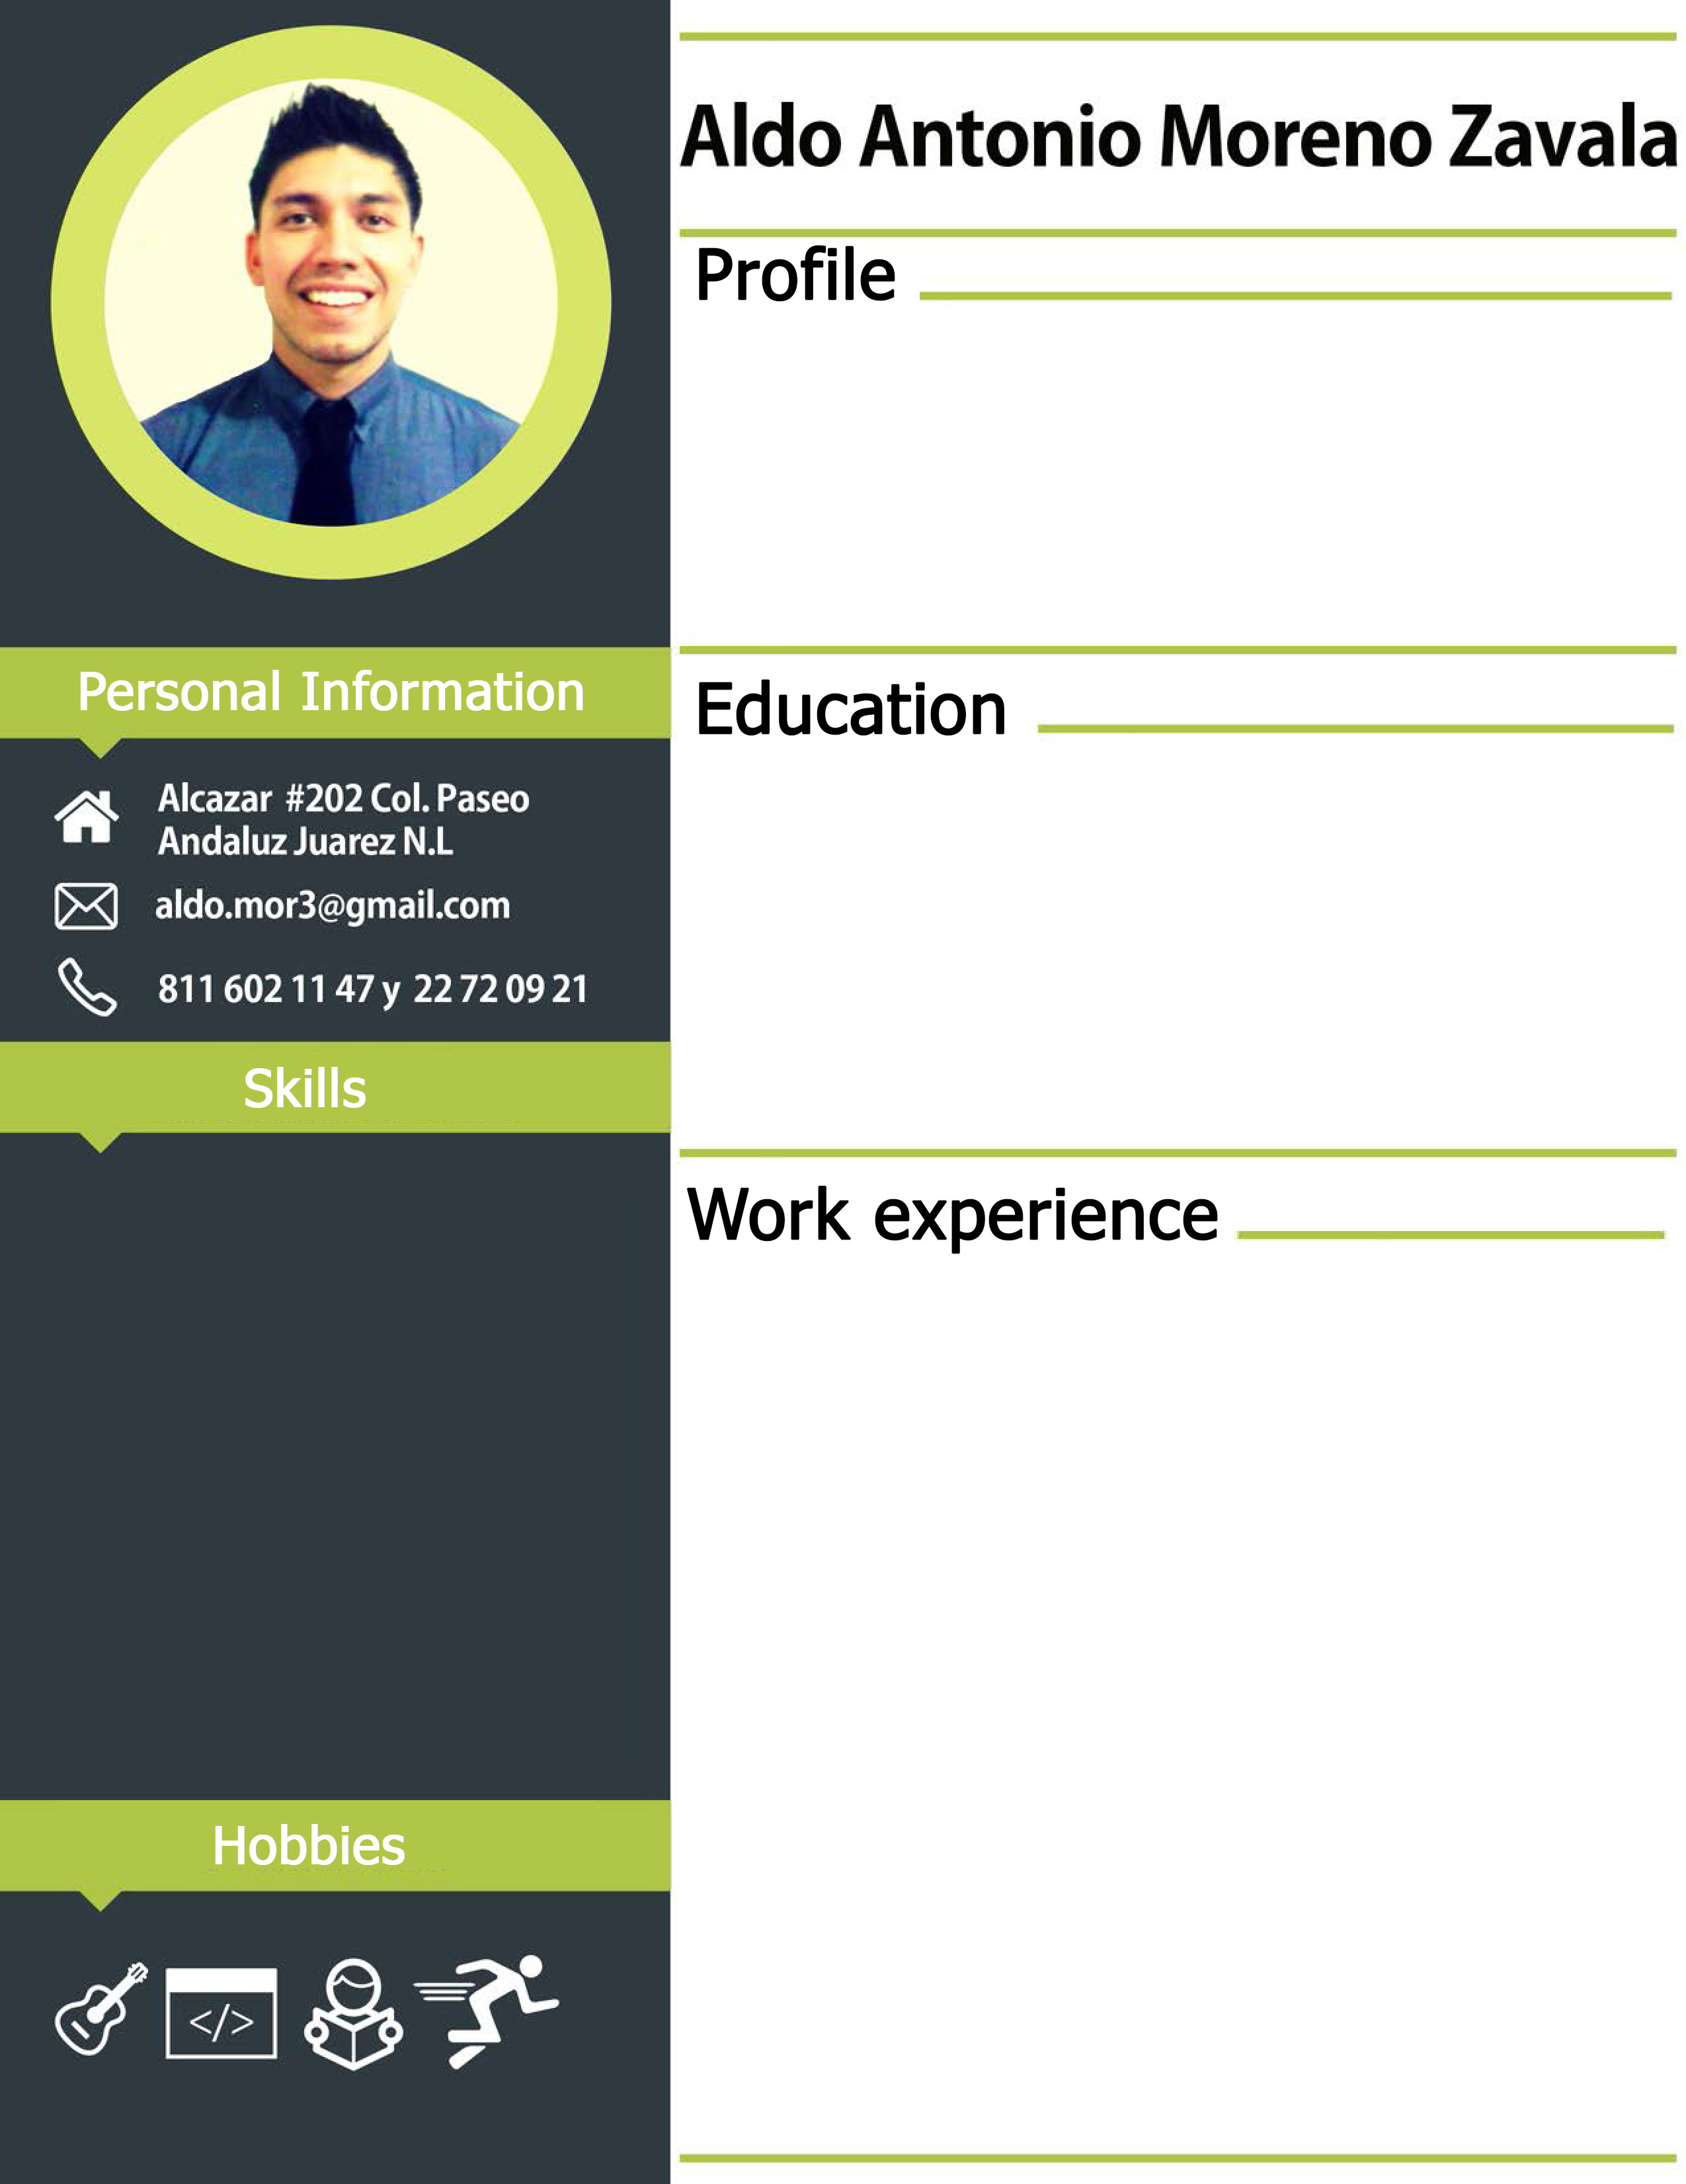

**Service Manager IT | INTELEXION**

* May 2017 – Present

- **Migration Web Application and SQL DB** [ Migration AWS infrastructure to Microsoft AZURE Cloud]

-**Azure Infrastructure** **Administrator** [ VM deployment , Virtual Network creation , Application Gateways, Insights , Server Health Monitoring, VPNs]

- **Office 365** **Administrator** [Managing Licenses , Exchange, Sharepoint, Onedrive]

-**Software Development**

* Helpdesk system [single sign-on with Active Directory, MVC C#, SQL DB, triggers Db, IIS, stored procedure, SignalR, ASP.NET Identity ,Powershell , WebApi, Controller, Angular js]
* Creation CFDI Module on Workbeat system [ stored procedure, OWIN, C#]

-**DB Administrator** [Managing access control to users, Managing SQL ports , SQL instances creation and Bakcup Jobs]

-**Firewall Administrator**[Deployment site to site VPN or tunnel interface, web content filtering ]

-**Windows Server Administrator**[ Monitoring Free space Disk by PowerShell scripting , Monitoring Windows updates using PowerShell, Managing access to users, Installing server roles like( FTP, IIS, ADFS, DNS), Installing SSL certificate on web servers]

* C# MVC
* SQL
* JAVASCRIPT
* HTML
* CSS
* AZURE CLOUD
* POWERSHELL

I consider myself as a person who likes challenges, because they continuously force me to improve myself. I’m software technology engineering focus in software development and cloud infrastructure.

**JANUARY 2011 – DECEMBER 2016**

**UNIVERSIDAD AUTONOMA DE NUEVO LEON.**

FACULTAD DE INGENIERIA MECANICA Y ELECTRICA.

**Software Technology Engineer.**